**Contents………………………………………………………………………Page Number**

1. Introduction……………………………………………………………………………………………1
   1. Aims/objectives………………………………………………………………………………..1
   2. Hypothesis………………………………………………………………………………………..2
   3. Methodology…………………………………………………………………………………….2
2. Findings…………………………………………………………………………………………………..3
3. Discussion……………………………………………………………………………………………….9
4. Conclusion……………………………………………………………………………………………..10
5. Reference List………………………………………………………………………………………..12
6. Appendix……………………………………………………………………………………………….13

**1. Introduction**

The rights and responsibilities in the United Kingdom vary from age to another. Sixteen years old UK citizens have the ability to move out from their parents’ houses without permission (Royal Borough of Kensington and Chelsea 2016). Moreover, at the age of 18; people are allowed to be married without a parental permission; they also could purchase a house, an apartment, or hold a tenancy (ibid). However, the life of independency is not always easy to tackle, especially for youth. According to the Homeless Link (2015), nearly 130,000 youth are seeking for help regarding being homeless or at risk of becoming one every year in the United Kingdom. In addition, the amount of people who sleep on the streets of London and aged between 18 and 24 has increased twice as much as before (ibid). Therefore, young people who have the right to become independent by leaving their parents’ home and be responsible for it are concerned about homelessness.

**1.2 Aims/objectives**

The aim of this report is to show that young people agree with the United Kingdom rights and responsibilities regarding their independence of living on their own more than elders. In addition, the report will be including topics that are related to independence such as the legal age, marriage, and financial support. Graphs and statistics will be also provided by this report in order to prove the hypothesis.

**1.3 Hypothesis**

“Young people in the United Kingdom are more likely to support the right to be independent and responsible to live on their own than older people.”

**1.4 Methodology**

This study will identify the reasons of youth aged between 16 to 20 years old who tend to agree with the rights of being independent and responsible of living on their own. On the other hand, older individuals that have 21 years old or above are less supportive than young people. Youth and elders were selected randomly in order to complete the survey (appendix 1). On the 12th to 14th of February 2016, a total of 20 people were asked to participate, 10 between the age of 16 to 20 and the other were 21 and above. This method was designed to balance the collected information to measure and analyze the statistics.

**2. Findings**

**Figure 2.1: At what age do you think a person should be able to buy their own house and live independently?**

Figure 2.1 above shows that half of the young people (16 to 20) wrote the age of 17 while half of the older people (20+) wrote 19 years old.

**Figure 2.2: Do you agree with this statement?**

**“A person should be able to get married without a parental permission starting from the age of 16.”**

Figure 2.2 indicates that most of the surveyed people disagreed with the statement.

**Figure 2.3: Do you think the legal age to buy alcohol drinks should be lowered from 18 to 16 years old?**

|  |  |  |  |
| --- | --- | --- | --- |
| **The Group Age:-** | **Yes** | **No** | **Maybe** |
| **Young People (16-20)** | 7 | 3 | 0 |
| **Older People (21+)** | 2 | 7 | 1 |

Figure 2.3 shows young people are more likely to agree with lowering the legal age of buying alcohol drinks than older people.

**Figure 2.4: If a person wants to leave their parents’ house, who do you think is responsible for taking the permission from?**

|  |  |  |  |  |
| --- | --- | --- | --- | --- |
| **The Participants:-** | **The Government** | **The Parents** | **No one** | **Others** |
| **Young People (16-20)** | 2 | 10 | 0 | 0 |
| **Older People (21+)** | 6 | 9 | 1 | 0 |

Figure 2.4 illustrates almost all the participants from both groups had selected The Parents option.

**Figure 2.5: The government should support married couples between the age of 16 and 18 (with or without parental permission) financially and secure a place for them to live in.**

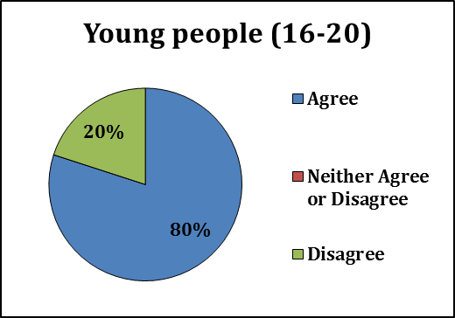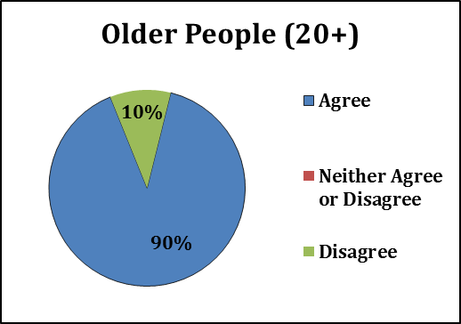

Figure 2.5 reveals both groups of young and older people agree to have a financial support from the government regarding young marriage.

**Question 2.6: Please list at least 1 advantage for young people who are between the age of 16 and 20 to live on their own.**

The most common written answer by young people is related to privacy, and some mentioned learning on how to become more independent and avoiding house rules from their parents. While half of the elders agreed on the same advantages. In addition, two elders ticked the no advantages option as an answer. Some participants from both groups have skipped the question.

**Figure 2.7: Do you think young people who live on their own are responsible to pay taxes once they leave their parents’ houses?**

Figure 2.7 shows that the majority of people from both sides answered yes, others answered no. 2 young people commented that it depends if the person has a job, an income, or not.

**Figure 2.8: At what age do you think a person should be able to have driving license to drive a car?**

Figure 2.8 illustrates that 50% of the elders had chosen the age 18 while 60% of youth said 17 and the rest were spread evenly.

**Question 2.9: What are the responsibilities for a 16 year old who lives on her/his own and being completely independent?**

Many young people and older people had the same answer, which is having a job or a great income and pay their taxes. However, some said that they also need to be aware of the laws and accept the consequences of breaking the law.

**Figure 2.10: On scale of 1 to 5 (1 being not capable at all, 5 being very capable), are young people who have 16 years old are capable to live on their own?**

Figure 2.10 shows the majority of young people wrote 3 which are in the middle of the scale, while older people were spread between 3 and 1.

**3. Discussion**

The objective of this report is to analyse the statistics and the collected information from the participants who answered the surveys. The hypothesis of this study has been slightly approved according to the findings section of this report. The results of this study indicates that many young people are tending to lower the legal age of some practices than elders, regarding independency such as marriage, housing, drinking and other related divisions.

The results from figure 2.1 indicate that 50% of the young people want to be independent by purchasing a house to live in at the age of 17. However, 50% of older people wrote 19 as the legal age to own a house. Figure 2.10 might explain the reason behind the results that are found for figure 2.1. The bar chart from 2.10 shows that youth think that a 16 years old person is capable to live on their own. By analysing it, the first results shows that younger individuals want to buy a place to be independent which figure 2.10 points out that this decision might be due to their confidence that they are capable to live by themselves. Therefore, figure 2.1 and 2.10 highlight a strong connection.

In question 2.9, both groups had almost the same answers. The most common ones are being employed and responsible of paying their taxes. These results could be related to the graph of 2.7 where many young and old individuals think that after leaving their parents; paying taxes is one of the responsibilities towards young people. A possible explanation for this might be that young people as well as elders think that the paid taxes should make the government to provide better utilities such as roads, and parks.

Another important finding related to the pie chart of 2.5 that indicates both youth and elders agree on 16 to 18 years old teenagers who are married to be financially supported by the government. 80% of youth have agreed on the statement; however, unexpected outcome from elders where 90% have agreed as well. That brings the analysis back to figure 2.10 where elders did not have a positive response, and they think that teenagers from 16 years old are not old enough to live independently. Therefore, that 10% increase could be due to that reason why elders think the government should help young couples financially.

An important result comes from the timetable 2.3 supporting the hypothesis of the report. Youth believe that the legal age of purchasing alcohol beverages should be lowered while elders think the opposite. This might be due to some young individuals would act recklessly when they drink.

**4. Conclusion**

The discussion section has analysed the important findings in order to prove or disapprove the hypothesis of the report. The hypothesis has been proven according to the majority of the findings where youth are leaning towards lowering the legal age. They also believe that they should be involved in many situations do not requires permissions. However, this report could have been more accurate if it did not have open questions since some participants left them blanked. In addition, only 20 people participated which made the results limited, also the elders that were asked seems to have an age above 30 or 40 which is a big gap between both groups. A possible recommendation could be that the government should reduce the age of the legal age of purchasing houses, alcohol, and marriage. Young people might be more satisfied than the current situation. As well as the community might change their perspective towards young people into a positive view.

**Reference List:-**

Homeless Link. 2015. *Young and homeless 2015* [Online]. Available at: http://www.homeless.org.uk/sites/default/files/site-attachments/201512%20-%20Young%20and%20Homeless%20-%20Full%20Report.pdf [Accessed: 28 February 2016].

The Royal Borough of Kensington and Chelsea. 2016*. Your rights at 18* [Online]. Available at: https://www.rbkc.gov.uk/subsites/kccentral/yourvoice/youthforums/yourrights/yourrightsat18.aspx [Accessed: 26 February 2016].

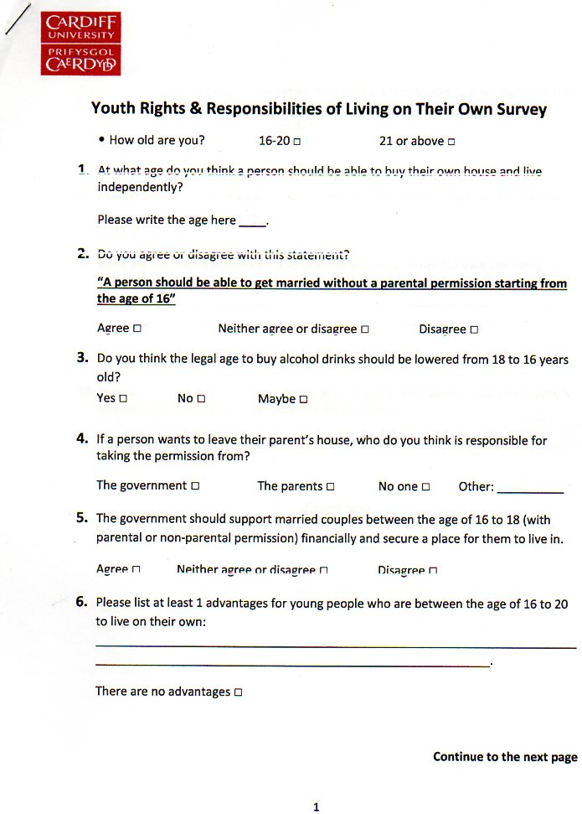**Appendix:-**

